https://www.thepaper.cn/newsDetail_forward_27937846

Summary of achievements in national defense and military reform since the Third Plenary Session of the 18th CPC Central Committee

Mei Shixiong Li Bingxuan/Xinhua News Agency
2024-07-02 23:29
On the great journey of the people's army to reform and strengthen the army, we have ushered in another important moment that will go down in history——
On April 19, 2024, the founding meeting of the Information Support Force of the Chinese People's Liberation Army was held grandly at the Bayi Building in Beijing. Xi Jinping, General Secretary of the CPC Central Committee, President of the State, and Chairman of the Central Military Commission, awarded the military flag to the Information Support Force and delivered a speech. On behalf of the Party Central Committee and the Central Military Commission, he extended warm congratulations to all officers and soldiers of the Information Support Force.
After the flag-presenting ceremony, Xi Jinping delivered a speech. He pointed out that the adjustment and formation of the information support force is a major decision made by the Party Central Committee and the Central Military Commission based on the overall situation of strengthening the military. It is a strategic measure to build a new structure of services and arms and improve the modern military force system with Chinese characteristics. It is also important for accelerating national defense and military affairs. Modernizing and effectively fulfilling the missions and tasks of the People's Army in the new era is of great and far-reaching significance.
According to the decision of the Central Military Commission, the newly formed information support force will be directly commanded by the Central Military Commission. At the same time, the designation of the strategic support force will be revoked, and the leadership and management relationships of the military aerospace force and cyberspace force will be adjusted accordingly.
Reform is the requirement of the times to realize the Chinese Dream and the dream of building a strong military. It is the only way to strengthen and rejuvenate the military, and it is also a key move to determine the future of the military.
Since the Third Plenary Session of the 18th Central Committee of the Communist Party of China, the People's Army has adhered to the guidance of Xi Jinping Thought on Socialism with Chinese Characteristics for a New Era, thoroughly implemented Xi Jinping Thought on Strengthening the Military, and guided the Party's goal of strengthening the military in the new era, comprehensively implementing the strategy of reforming and strengthening the military. , deeply break through the institutional obstacles, structural contradictions, and policy issues that have long restricted national defense and military construction, deepen the reform of national defense and the military, and achieve historic achievements. The people's army has a new system, a new structure, a new pattern, and a new look. Take firm steps on the road to building a strong military with Chinese characteristics.
Reform promotes a strong military, and a strong military supports a strong country. Standing at a new historical starting point, under the strong leadership of the Party Central Committee with Comrade Xi Jinping at its core, the People's Army has achieved overall revolutionary reshaping and is making strides to become a world-class force, providing strategic support for the great rejuvenation of the Chinese nation.
Strategic planning, commander-in-chief steering the ship
Reform is the distinctive feature of contemporary China and the distinctive character of the Communists.
Since the 18th National Congress of the Communist Party of China, socialism with Chinese characteristics has entered a new era, and national defense and military building have also entered a new era. Faced with the strategic overall situation of the great rejuvenation of the Chinese nation and the world's major changes unseen in a century, as well as the deep-seated contradictions and problems that have long restricted the construction of national defense and the military, President Xi assessed the situation, took charge of the overall situation, and decisively made strategic decisions to reform and strengthen the military.
A strong country must have a strong army, and a strong army must be reformed. "Once military backwardness occurs, the impact on national security will be fatal. I often read some historical materials in modern China, and it hurts my heart to see the tragic scenes of backwardness and beatings!" President Xi pointed out with strong historical concern. , National defense and military reform is an important part of comprehensive reform and an important symbol of comprehensively deepening reform. The military must keep up with the pace of the central government and resolutely promote various military reforms in the spirit of opening roads across mountains and building bridges across rivers. Everyone must have this kind of historical responsibility.
Only reformers advance, only innovators are strong. President Xi encouraged the entire army: "The new military revolution provides us with a once-in-a-lifetime opportunity. We must seize the opportunity and work hard. We must not only catch up with the trend and the times, but also strive to be at the forefront of the times."
After the founding of the People's Republic of China, our army has carried out 13 relatively major reforms. The size and structure of the army have been continuously adjusted, and they have played an important role in different historical periods. At the same time, affected by various factors, deep-seated contradictions that restrict national defense and military construction still exist to varying degrees.
"The reform of national defense and the military has entered a critical period and a deep-water zone. Most of the problems that need to be solved are long-term accumulated institutional obstacles, structural contradictions, and policy issues. It is indeed not easy to advance." President Xi warned the entire army, "Not reforming is a waste of time. You can’t fight and win the battle.”
The more you think deeply, the more earnestly you act.
In November 2013, the Third Plenary Session of the 18th CPC Central Committee was held. The Party Central Committee decided to include deepening the reform of national defense and the military into the overall plan of comprehensively deepening reforms, making it the will of the Party and the behavior of the state.
This is the first time in the history of the plenary session that national defense and military reform were included in the plenary session's decision as a separate part.
Only four months later, another blockbuster news attracted widespread attention at home and abroad: President Xi decided to establish a Central Military Commission leading group for deepening national defense and military reform and served as the group leader. This is also the first time that the General Secretary of the Party personally serves as the leader of the Central Military Commission’s Leading Group for Deepening National Defense and Military Reform.
These two extraordinary "firsts" demonstrated the firm will and determination of the core of the Party, the commander-in-chief of the army, and the people's leaders to deepen the reform of national defense and the army. They greatly inspired and gathered all the officers and soldiers to support the reform and support the reform. The majestic force of reform and devotion to reform has become the fundamental guarantee for promoting reform.
For a major country's military, the question of what to change and how to change it involves issues of goals and layout, issues of stance and perspective, as well as issues of methods and paths. President Xi has put a lot of effort into the reform demonstration and design. He has chaired many meetings of the Central Military Commission’s Leading Group for Deepening National Defense and Military Reform, Central Military Commission Standing Meetings, and Central Political Bureau Standing Committee meetings. He has listened to the reform opinions and suggestions of relevant units in person on many occasions, and personally determined the reforms. Arrange major work, personally lead the research, demonstration and plan formulation work, personally organize research on major reform issues...
Reform always pursues problems and uses problems to force reform. At each stage of reform, each plan pointed out the method and path to solve practical problems, and the solutions to each practical problem eventually converged into specific reform measures.
Deepening the reform of national defense and the military is a comprehensive change that requires strengthening top-level planning and system design. At an important meeting of the military, President Xi emphasized the need to grasp the relevance and coupling of reform measures so that various reforms such as leadership and command systems, force structures, and policy systems can promote and complement each other to form an overall effect and achieve overall results.
Plan the layout of the article and make a sound decision.
Establish an expert advisory group of the Central Military Commission’s Leading Group for Deepening National Defense and Military Reform; establish an expert database for consultation and evaluation of military policy system reform consisting of more than 200 military and civilian experts and leaders to give full play to the role of third-party independent evaluation; empower the Academy of Military Science and the National Defense University with relevant Research and demonstrate tasks and play its role as a think tank...
Gather the wisdom of the entire military and all sectors to form the "greatest common denominator" for reform. President Xi visited institutions, joined squads, went to plateaus and islands, boarded tanks, and took warships to conduct in-depth investigations and studies. The whole army and all aspects actively offer suggestions and suggestions, from outside the military to inside the military, from agencies to troops, from generals to soldiers; on-site surveys in all directions, interviews at all levels, and large-scale questionnaire surveys; one situation report after another, and one letter after another Opinions, online messages... many good ideas, suggestions, and ideas have entered the reform plan.
"Anything that can be done with concentrated effort will be invincible; anything that can be done with collective wisdom will be successful." Under the leadership and planning of President Xi, a set of reform designs that solve deep-seated contradictions, have major innovative breakthroughs, and have distinctive characteristics of the People's Army Break out of the cocoon.
In July 2015, President Xi presided over the meeting of the Central Military Commission’s Leading Group for Deepening National Defense and Military Reform, the Central Military Commission Standing Meeting and the Central Political Bureau Standing Committee meeting, and reviewed and approved the overall plan for deepening national defense and military reform.
In the process of leading this round of reforms, President Xi Jinping has issued a series of directional, fundamental and overall important strategic thoughts on deepening the reform of national defense and the military, which have established the fundamental principles and action guidelines for reforming and strengthening the military.
From the overall layout of the party and the country to the mutual coupling of various military systems, from the overall plan, major field plans to special plans, and from the leadership and command system, the size, structure and strength of the army to the orderly advancement of the reform of military policies and systems, the new era The goal map, road map and construction drawings for the reform of the People's Army were thus drawn up, and a historic change of rebirth from the ashes and new development was vigorously launched.
Overcome difficulties and advance reforms in depth
A history of the development of the people's army is a history of reform and innovation.
November 24, 2015, is a day destined to go down in the history of the People’s Army. The Central Military Commission Reform Work Conference was held grandly in Beijing. President Xi issued a mobilization order to deepen the reform of national defense and the military—to comprehensively implement the strategy of reforming and strengthening the military and unswervingly follow the path of strengthening the military with Chinese characteristics.
When the commander-in-chief orders, the entire army obeys the order, unites to the center, exerts force for the battle, and overcomes difficulties.
The leadership and command system achieves historic changes——
The reform of the leadership and command system implements the general principles of the Central Military Commission, the main battle areas, and the military services, breaking the long-standing headquarters system, large military region system, and large army system, and building a leadership and management system of "Central Military Commission-Services-troops" and " The combat command system of "Central Military Commission - Theater - Troops" has established a new "four beams and eight pillars" of the people's army. The "Four Headquarters" have withdrawn from the historical stage, and 15 functional departments of the Central Military Commission have been adjusted and established. The paths of command, construction, management, and supervision have become clearer. Functional configurations such as decision-making, planning, execution, and evaluation have become more reasonable. The Central Military Commission has centralized and unified leadership and strategic planning, Strategic management functions have been effectively strengthened. The "Seven Military Regions" have completed their historical missions, reorganized and divided into five major theaters, improved the military commission and theater joint operations command structure, and established a strategic campaign command system that integrates peacetime and wartime operations, operates normally, specializes in main operations, and is capable and efficient. The leadership and management system of the services and arms has been further improved. The Armed Police Force is under the centralized and unified leadership of the Party Central Committee and the Central Military Commission. The reserve forces are fully integrated into the military leadership and command system. Entering the "new system era", the majority of officers and soldiers have both "changed their bodies" and "changed their minds", liberating themselves from all outdated mindsets, inherent patterns, and path dependencies. The barriers to alliances have gradually been broken down, and the effectiveness of warfare has gradually become more apparent.
In drill after drill, units of different services and arms that used to be relatively independent carried out joint exercises and training on a regular basis under the dispatch of the theater; data and information that were difficult to share in the past are now efficiently circulated among units of various services and arms in the theater; reconnaissance is no longer " "Each one fights", the commander no longer "sings his own tune", and the firepower no longer "fights his own thing", each one is born through the tempering of the iron fist.
The size, structure and strength of the army have been profoundly reshaped——
This is new data that has never appeared in the history of the people's army: the proportion of the army's total personnel in the army has dropped to less than 50%; the number of active-duty personnel in non-combat agencies of the entire army has been reduced by nearly half, and the number of officers has decreased by 30%...
This is a new term that has never appeared in the history of the people's army: synthetic brigade, air assault brigade, aircraft carrier formation, airborne force, information support force, joint logistics support force...
The dialectic of reduction and increase is not only slimming down, but also strengthening the body. It is an epoch-making reshaping of strength. The reform of scale structure and force organization promotes the development of the army in the direction of enrichment, synthesis, multi-functionality and flexibility.
On April 27, 2017, the Ministry of National Defense disclosed at a regular press conference that the designations of 18 army groups of the Army were cancelled, and the designations of the 13 adjusted armies were announced at the same time. In addition, the newly adjusted units also include many new combat forces.
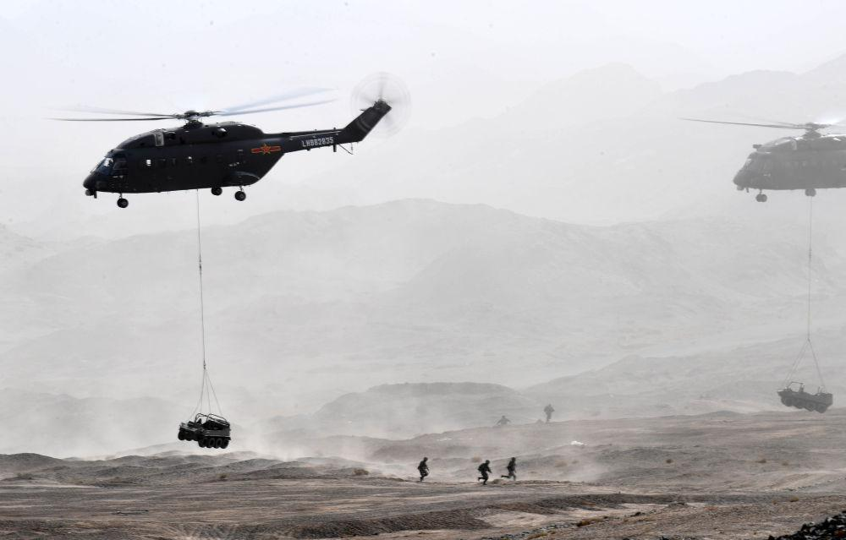
During the Army's war preparation and transformation training, an air assault brigade conducted a live-fire drill (photo taken on May 23, 2018). Photo by Xinhua News Agency reporter Zhang Yongjin
After the adjustment, our army has become more capable in scale, more optimized in structure, and more scientific in its organization. It has fundamentally changed the long-term land warfare-type force structure, changed the homeland defense-type force deployment, and changed the heavy-force grouping and victory with quantity. New combat forces such as strategic early warning, open sea defense, long-range strike, strategic projection, and information support have been enriched and strengthened, and a joint combat force system with elite combat forces as the main body is taking shape.
The reform of military policies and systems has been comprehensively advanced——
Recently, civilian personnel who have been recruited for the 2024 open recruitment for the entire army have been reporting to various units. In June 2018, the military openly recruited civilian personnel for the first time. Among the recruited personnel, groups with high academic qualifications and "secondary enlistment" groups were particularly eye-catching. This marks that the openness and competitiveness of our military's talent introduction work have been greatly enhanced. Civilians are an integral part of the military personnel and play an increasingly important role.
Let the vitality of all combat effectiveness elements burst out, and let the sources of all military modernization fully flow. The establishment and improvement of the new civilian personnel system is a vivid epitome of the policy and system reform of the people's army.
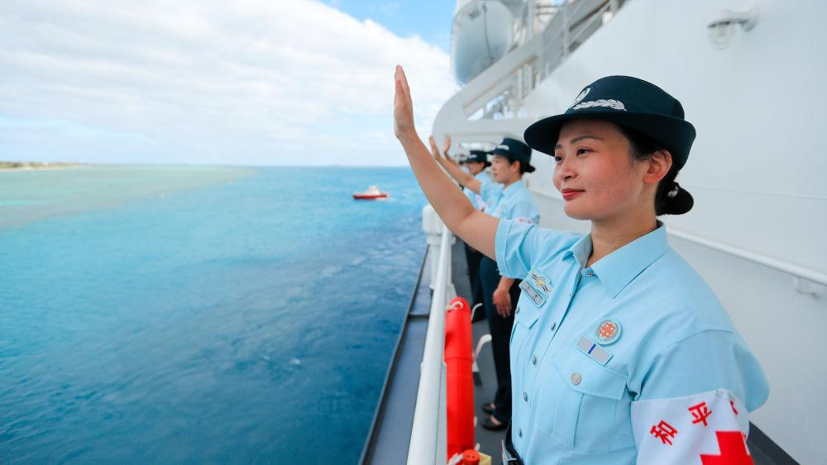
When the Chinese Navy hospital ship "Peace Ark" concluded its visit to Tonga, civilian personnel among the mission officers and soldiers waved goodbye to the farewell crowd (photo taken on August 4, 2023). Published by Xinhua News Agency (Photo by Xu Wei)
This reform has completely changed the previous piecemeal approach. Systematic planning, forward-looking design, innovative development, and overall reshaping have established and improved the socialist military policy system with Chinese characteristics, forming a military party building system, a policy system for the use of military power, and a military power building system. The "four major sections" are policy system and military management policy system.
President Xi presided over a meeting of the Political Bureau of the CPC Central Committee, which successively reviewed and approved the "Regulations on Party Building of the Chinese Communist Party in the Military", "Regulations on Military Political Work" and other backbone systems for party building in our military. The Standing Committee of the National People's Congress has successively reviewed and adopted the newly revised National Defense Law of the People's Republic of China, the newly revised Military Service Law of the People's Republic of China, and the Law of the People's Republic of China on the Protection of the Status and Rights and Interests of Military Personnel.
Establish a leading group for talent work of the Central Military Commission and establish a cadre evaluation committee of the Central Military Commission. The "Interim Regulations on the Management of Active Military Officers" and 11 supporting policies and systems were promulgated, and substantial progress was made in establishing a professional system for military officers with Chinese characteristics. The "Interim Regulations for Sergeants", "Interim Regulations for Conscripts", the newly revised "Regulations on Civilian Personnel of the Chinese People's Liberation Army" and supporting regulations were promulgated.
Build a military honor system and hold honor and title ceremonies; optimize military benefits, issue support subsidies to military parents and spouse honorary funds, and implement new medical security policies such as free medical care for military spouses and children... Each heart-warming event enhances the professional honor of officers and soldiers sense, making military personnel a profession respected by the whole society.
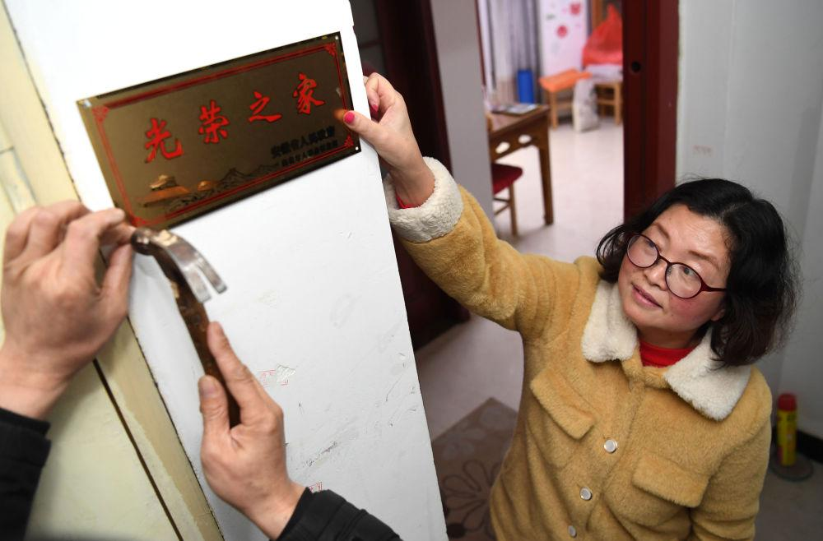
Staff from Changqing Street, Baohe District, Hefei City hang a "Glorious Home" sign at the door of resident Wei Songmei (right) (photographed on January 14, 2019). Photo by Xinhua News Agency reporter Liu Junxi
The reform of military policies and systems has matured one by one. Basic laws and regulations in more than 20 major fields have been introduced one after another. A large number of supporting policies and systems and major reform measures have been intensively introduced. The combat effectiveness of the military and the vitality of officers and soldiers have been further liberated, and the effectiveness of reforms has been continuously released.
Major reforms across the military and civilian areas are implemented in depth——
"Coordinate economic construction and national defense construction, and strive to achieve the unity of enriching the country and strengthening the military." Since the 18th National Congress of the Communist Party of China, President Xi has attached great importance to major cross-military and local reforms, and has made many deployments to promote the implementation of a series of measures.
Just after the Spring Festival in 2018, the Third Plenary Session of the 19th Central Committee of the Communist Party of China reviewed and approved the "Decision of the Central Committee of the Communist Party of China on Deepening the Reform of the Party and State Institutions" and the "Plan for Deepening the Reform of the Party and State Institutions". Deepening cross-military and civilian reforms is an important part of it.
Combined with deepening the reform of party and state institutions, deepen the cross-military reform of the Armed Police Force, promote the reform of the active public security force, and establish the Department of Veterans Affairs; implement the reform of the air traffic control system, establish the Central Air Traffic Management Commission; promote the reform of the national defense mobilization system, and create a modern national defense Mobilize the force system; completely stop paid military services, and the goal of the military not engaging in business activities has been basically achieved...
“With all our efforts, nothing can be done.” Central state agencies, local party committees, governments, and all sectors of society have introduced a series of policies and measures to support and serve reform, and the military and civilians have gathered a powerful force to promote reform.
In the late autumn of 2021, the "Resolution of the Central Committee of the Communist Party of China on the Major Achievements and Historical Experience of the Party's Centenary Struggle" passed by the Sixth Plenary Session of the 19th Central Committee of the Communist Party of China fully affirmed the historic achievements made in deepening the reform of national defense and the army, calling it "New China" The most extensive and profound reform of national defense and the military since its establishment."
Restructure and reshape to become world-class
Reform and strengthening the military have brought about a series of profound changes to the people's army. The people's army has accelerated its transformation in the "new system era": the army's mobile combat and three-dimensional offensive and defensive capabilities have been significantly enhanced, and the navy has accelerated its transformation from offshore defense to far sea defense. The Air Force is accelerating its transformation into an integrated air and space system with both offensive and defensive capabilities. The Rocket Force continues to strengthen its nuclear and conventional capabilities and its ability to deter war in all areas...
This is the new look of the People’s Army as a strong military after reform and reshaping——
In July 2023, at the Air Force Aviation Open Event Changchun Air Show, the J-20 performed maneuvering flight demonstrations in a four-aircraft formation for the first time. The screen was displayed for aerial refueling, and the J-10S and J-11BS were displayed for the first time in simulated air combat of special-shaped aircraft...
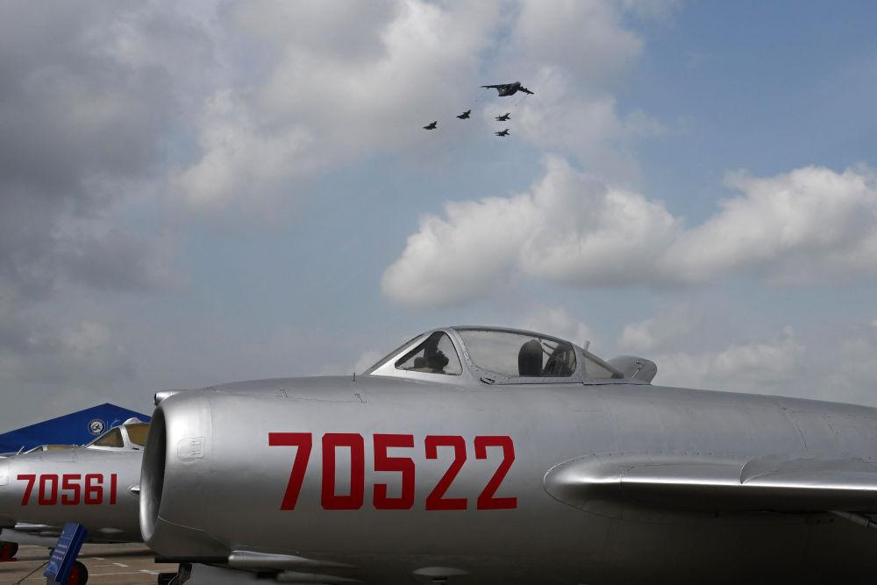
At the Air Force Aviation Open Event Changchun Air Show, the Yunyou-20 and J-20 and J-16 refueling formations flew over MiG-15 aircraft (photo taken on July 29, 2023). Published by Xinhua News Agency (Photo by Yu Hongchun)
This event demonstrated the People's Air Force's ever-changing equipment development level, the quality and effectiveness of practical military training, and its strategic capabilities to defend national sovereignty, security, and development interests.
"The Yunyou-20 is no longer a single static display and a single flight display, but an all-round presentation of the system's capabilities, displaying combat postures commonly used in our daily combat training." Wang Yuling, pilot of the Yunyou-20, said, "The reform has strengthened the The military strategy has enabled the people's army to achieve historic changes in its organizational structure and force system. It is precisely because of the reform that our army has been reshaped and accelerated to become a world-class force."
On October 1, 2019, more than 200,000 soldiers and civilians celebrated the 70th anniversary of the Republic of China with a grand military parade and mass march.
This is the first National Day military parade as socialism with Chinese characteristics enters a new era, and it is also the first overall appearance of the Republic's armed forces after the reform and reshaping.
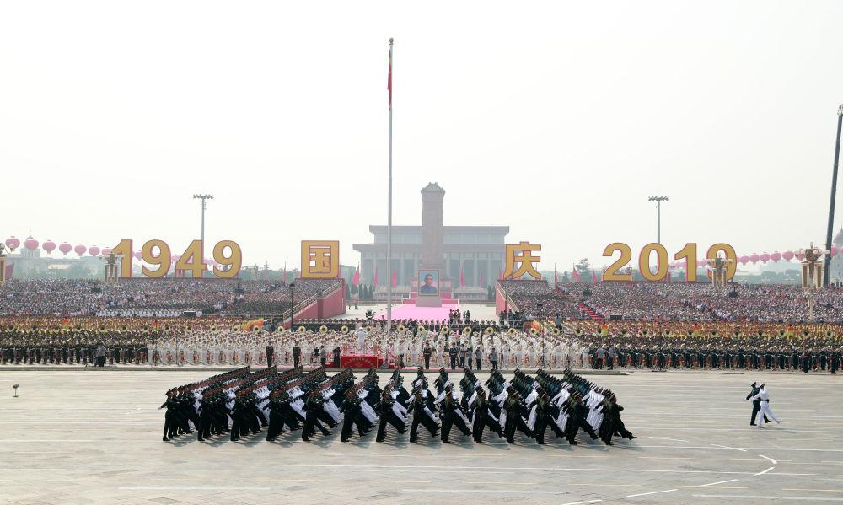
On the morning of October 1, 2019, a meeting to celebrate the 70th anniversary of the founding of the People's Republic of China was held grandly in Tiananmen Square, Beijing. This is the leader commanding the formation to be reviewed. Photo by Xinhua News Agency reporter Pang Xinglei
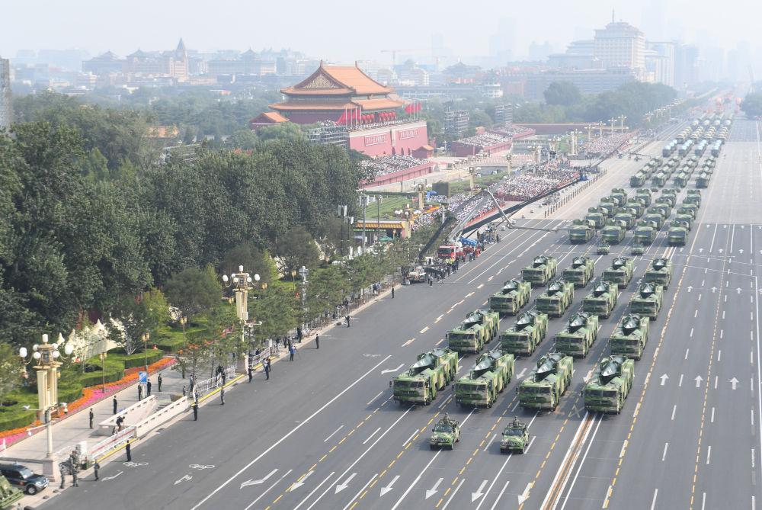
On the morning of October 1, 2019, a meeting to celebrate the 70th anniversary of the founding of the People's Republic of China was held grandly in Tiananmen Square, Beijing. This is the equipment parade passing through Tiananmen Square. Photo by Xinhua News Agency reporter Pubu Tashi
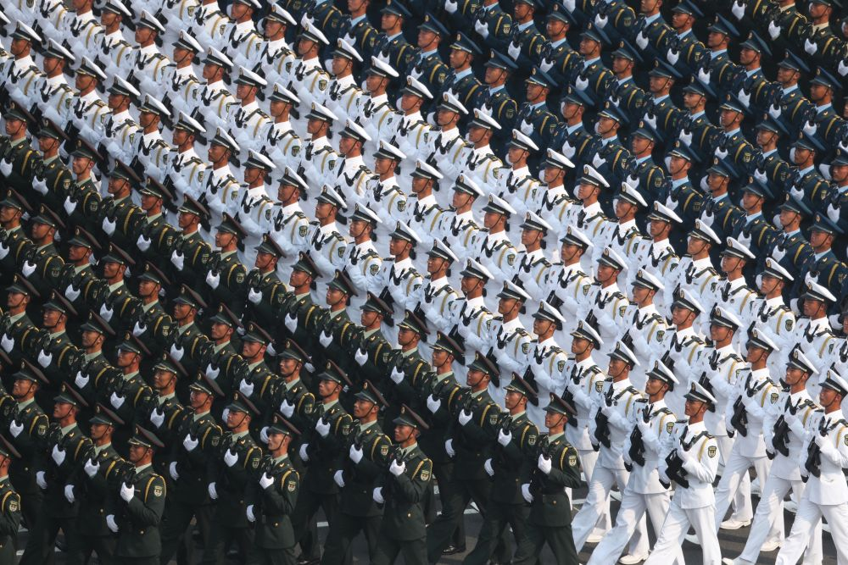
On the morning of October 1, 2019, a meeting to celebrate the 70th anniversary of the founding of the People's Republic of China was held grandly in Tiananmen Square, Beijing. This is the joint logistics support force formation. Photo by Xinhua News Agency reporter Jiang Hongjing
The leadership and command formation that made its debut is a formation with the most distinctive imprint of reforming and strengthening the army and joint combat command - the members are drawn from 15 departments of the Central Military Commission and various war zones, service and arms agencies, and armed police forces.
The leadership and command formation created two firsts: the first formation in the history of the People's Army military parade to be drawn from the leadership and command organization, and the first formation with generals forming the first row.
For the first time, this military parade has set up joint support forces, academic scientific research, civilian personnel and other formations, demonstrating the results of the integral and revolutionary reshaping of the national defense and military organizational structure and force system, and demonstrating the new composition of the people's army in the new era. , new look.
580 pieces (sets) of ground equipment formed 32 equipment formations, and more than 160 fighter planes of the army, navy and air force formed 12 air echelons... The equipment reviewed was all made in China, 40% of which were made for the first time, demonstrating the basics of the people's army. Achieve mechanization and accelerate the momentum towards informatization.
This is the more capable and efficient command system displayed by the People’s Army after reform and reshaping——
From May 23 to 24, 2024, the Eastern Theater Command of the Chinese People's Liberation Army organized the theater's army, navy, air force, rocket force and other forces to conduct the "Joint Sword-2024A" exercise around Taiwan Island.
The exercise focuses on subjects such as joint naval and air combat readiness patrols, joint seizure of comprehensive battlefield control, and joint precision targeting of key targets. Ships and aircraft conduct combat patrols near Taiwan Island, and integrate internal and external linkage within the island chain to test the actual joint combat capabilities of the theater forces.
This is also a strong punishment for the "Taiwan independence" separatist forces seeking "independence" and a serious warning against interference and provocation by external forces.
Military experts believe that during the exercise, under the unified command of the Eastern Theater Command, the theater's army, navy, air force, rocket force and other services jointly participated, demonstrating the collaborative capabilities and overall operations of the Chinese military in joint operations after reform and reshaping. strength.
More than 4 years ago, the COVID-19 epidemic broke out.
With an order, medical personnel from the Army, Navy, Air Force, Rocket Force, Joint Logistics Support Force, Armed Police Force and other medical units quickly gathered to assist Wuhan.
Aviation, railways, highways, three-dimensional delivery; efficient circulation of manpower, materials, and information; active military personnel, civilian personnel, and militiamen, working closely together; joint command, joint formation, military-civilian joint...
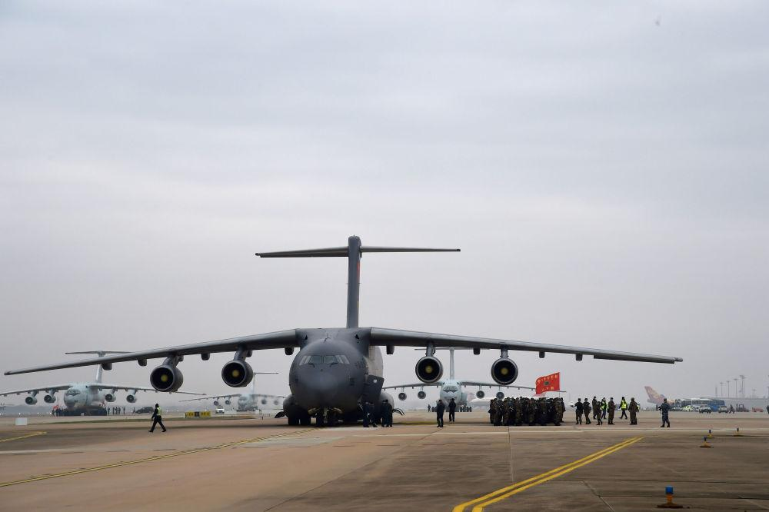
The Air Force dispatched 11 Type 3 transport aircraft to simultaneously airlift medical team members to Wuhan (photo taken on February 13, 2020). Photo by Xinhua News Agency reporter Li Yun
"Getting into the state quickly, assembling troops quickly, and launching operations quickly, this is the real speed of war." "Command and coordinate a picture, use strength as a game, and implement every move. This is the real war system." Some military observers commented this way The performance of the Chinese military in the anti-epidemic operation in Wuhan. There was no preparation time, no battle rehearsal, and the decisive battle was the first battle. In this special battle, the People's Army handed over an excellent answer sheet of "going to the front line on the day of receiving the order, controlling the situation in 3 weeks, and completing the task within 3 months." This miraculous "speed" stems from the more efficient command system, leaner force scale, and more scientific structure after the reform and reshaping of the People's Army.
"The People's Army's anti-epidemic response sheet condenses the reshaping of the People's Army's capabilities and the changes of the times, and demonstrates the new look and confidence of an army after reform and reshaping." Academician of the Chinese Academy of Sciences, Institute of Systems Engineering, Academy of Military Sciences Researcher Yin Hao believes that although the fight against the epidemic is a non-war military operation, it tests and reflects the actual combat capabilities of the people's army after reform and reshaping.
Military experts believe that after the reform and adjustment, the entire army has further strengthened the concept of preparing for war and joint operations and joint training. Each theater has played the role of a hub for joint operations and joint training, and all services and arms units have closely aligned with the joint operations capability needs of the theater, and trained with the capabilities of the services and arms. Support system joint training to continuously improve the victory contribution rate.
This is the new training style explored by the people’s army after reform and reshaping——
From September 11 to 25, 2021, the "Peace Mission-2021" SCO joint anti-terrorism military exercise was held at the Donguz shooting range in Orenburg Oblast, Russia.
In this joint exercise, the command structure of the Chinese participating troops is mainly composed of the Chinese directing department and the Chinese anti-terrorism cluster command headquarters in the northern theater. The task force is mainly composed of a synthetic battalion of a brigade in the northern theater and is equipped with relevant support detachments.
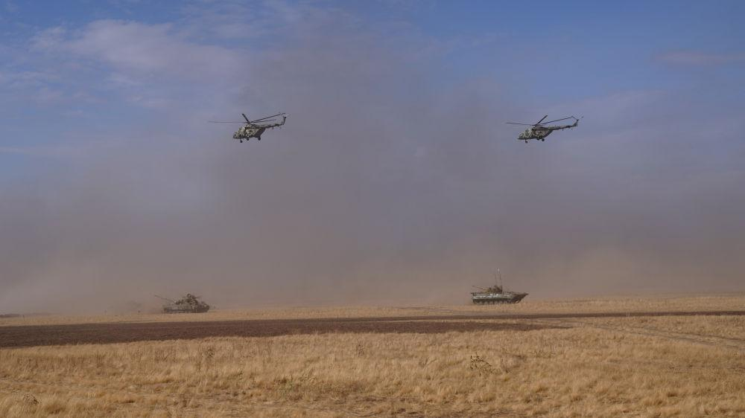
On September 23, 2021, during the "Peace Mission-2021" Shanghai Cooperation Organization joint anti-terrorism military exercise live-fire exercise held at the Donguz shooting range in Orenburg Oblast, Russia, multinational joint forces conducted coordinated land and air operations. Photo by Xinhua News Agency reporter Mei Shixiong
Under the new system and new organization, the combined battalion of Chinese participating troops includes infantry, armor, artillery, reconnaissance, communications, engineering and other forces. It integrates multiple arms and realizes the strength structure, personnel organization, equipment deployment, The reshaping and leapfrogging of element grouping can be combined with a variety of combat forces and modularized, giving full play to its advantages of miniaturization, multi-functionality, and leanness, so that each combat unit and element can maximize the system's combat capabilities.
During a live-fire exercise on September 23, reporters saw the modular and multi-functional combat organization advantages of the combined battalion in a new combat command vehicle, boldly practicing multi-source perception of combat command, high integration of combat elements, and combat space orientation. The multi-dimensional expansion of the new combat style maximizes the role of the combined battalion's "forward reach".
On July 23, 2023, with the successful conclusion of the "Anchorage Defense" drill of the ship formation, the "Northern Joint-2023" exercise completed various scheduled drill courses.
The exercise focused on the theme of "Maintaining the Security of Strategic Maritime Channels". The naval and air forces of China and Russia jointly planned, jointly commanded, and jointly operated. It effectively tested the actual combat capabilities in far seas and remote areas, and made achievements in the joint exercise organization form and force integration model. An innovative breakthrough.
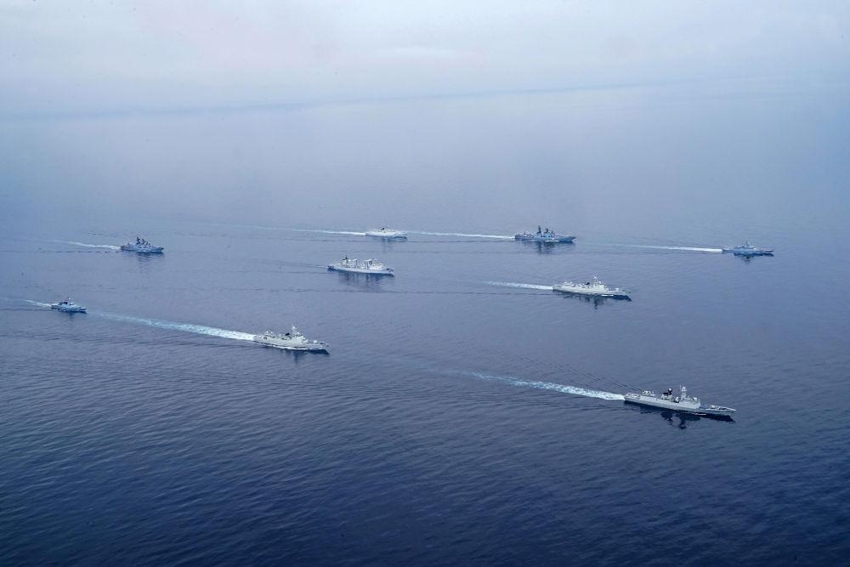
On July 20, 2023, during the "Northern United-2023" exercise held in a certain area of ​​the Sea of ​​Japan, Chinese and Russian participating ship formations conducted sea and air escort exercises. Published by Xinhua News Agency (Photo by Liu Dan)
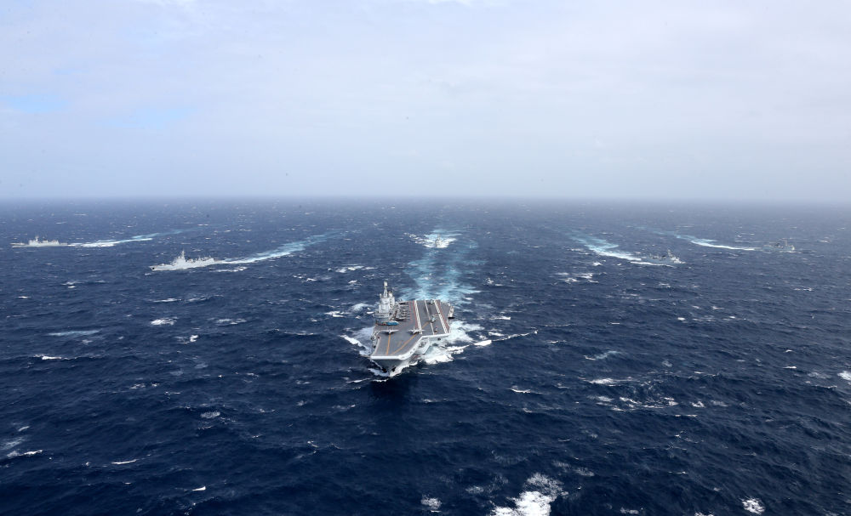
The Navy's Liaoning aircraft carrier formation sails towards the Western Pacific (file photo). Published by Xinhua News Agency (Photo by Mo Xiaoliang)
On May 17, 2024, the China-Mongolia "Grassland Partner-2024" joint army training was the first all-element and full-process live-fire training, which was held at a training ground in East Gobi Province, Mongolia.
The participating troops from China and Mongolia jointly carried out joint training on the topic of dealing with the activities of illegal armed groups in accordance with the basic tactics of "attacking key points from all depths, concentric assaults from multiple directions, and clearing and encircling and annihilating in different areas".
……
New systems, new forces, new equipment, new tactics... the people's army has taken on a new look from the inside out, and is more confident in deterring the enemy with its sword.
There is no end to reform. The people's army that marches forward courageously on the road to reform and strengthen the army will surely continue to win new victories in the modernization of national defense and the army——
In 2027, the centenary goal of the founding of the army will be achieved;
By 2035, basically realize the modernization of national defense and the army;
By the middle of the 21st century, the people's army will be fully developed into a world-class army...

